**Documentation for the Museai**

**Content**

**Introduction ----------------------------------------------------------------------------------------- 2**

**Microsoft Azure ----------------------------------------------------------------------------------------- 2**

**Resource Group ---------------------------------------------------------------------------------- 2**

**Web Portal ---------------------------------------------------------------------------------------- 2**

**Diagram --------------------------------------------------------------------------------------------**  **3**

**Contextual Diagram --------------------------------------------------------------------------------------- 4**

**Museai Database -------------------------------------------------------------------------------- 5**

**Web App ----------------------------------------------------------------------------------------- 5**

**Progressive Web Application ----------------------------------------------------------------- 5**

**Optional Model --------------------------------------------------------------------------------------------- 6**

**Rules ------------------------------------------------------------------------------------------------ 6**

**Security -------------------------------------------------------------------------------------------- 6**

**Progressive Web Application --------------------------------------------------------------------------- 7**

**Research ------------------------------------------------------------------------------------------- 7**

**Develop Feature --------------------------------------------------------------------------------- 7**

**Diagram -------------------------------------------------------------------------------------------- 8**

**Timeline -------------------------------------------------------------------------------------------- 8**

**Web Application -------------------------------------------------------------------------------------------- 8**

**Language ------------------------------------------------------------------------------------------- 8**

**Backend -------------------------------------------------------------------------------------------- 8**

**Frontend ------------------------------------------------------------------------------------------- 8**

**Application Architecture --------------------------------------------------------------------------------- 9**

**Client Application ------------------------------------------------------------------------------- 9**

**Server Application ------------------------------------------------------------------------------ 9**

**Server Architecture --------------------------------------------------------------------------------------- 11**

* **Model View Controller ------------------------------------------------------------------------ 11**
* **Cross Origin Resources Sharing ------------------------------------------------------------- 11**
* **Route --------------------------------------------------------------------------------------------- 11**

**Entity Relationship Diagram ---------------------------------------------------------------------------- 12**

**Introduction**

Museai is a building where historical, scientific, aesthetic, artistic or culturally significant things are preserved and exhibited.

The goal is to create a new application using Microsoft Azure Portal that allows hearing people to read information from Museai and hear the information read aloud when they select one of the pictures, while deaf people may read the information or watch a video of the sign language when they select one of the pictures.

**Microsoft Azure Portal**

Azure Portal is a public cloud computing platform that can be used to run museai software online and includes features including analytics, virtual machines, storage, database, networking, web apps, and more. The Azure Portal is a single location where developers can access and manage the museai app, as well as other apps. They may utilize a single interface to create, manage, and monitor their simple web apps (museai) and complex cloud apps.

If you want to learn more about Azure Portal, please visit at: <https://azurelessons.com/azure-portal/>

**How to use the Azure Portal Account?**

* Go to the url: [https://portal.azure.com](https://portal.azure.com/)
* Ask for your email address; use this one (cat@rit.edu) and password (please ask Byron Behm for the password) to access the Azure Portal that relates to cat’s Microsoft account.
* Or if you don’t have the Azure Portal account on Microsoft, please create a new account.
* Go to the Resource Group where MUSEAI and others exist in the list.
* Then click one “MUSEAI” in the list and next to where you can see the Database for MySQL, Storage, App Server Plan, Web App (museai) and others exist in the list.
* If you want to see the web app (museai with App Service Plan), click one in the list, click the url of the museai or copy and paste this (http://museai.azurewebsites.net) on the right of the top. Then click the “MUSEAI RIT” on the left on the top. You will see museai’s web app. Then create your new role and password and then access the page using login.
* If you want to see the Database for MySQL, click “catic21museai” in the list and it will display all the information there.
* If you want to see all files exist in the folder, click museaistorage in the list and then click blog, and container in the left side.
* For your information, all databases for MySQL, Storage, Web apps, and App Server Plan require you to create a new account for future security reasons.

Resource Group called **MUSEAI**

* Service Authentication
* Microsoft Azure Storage
* Database for MySQL
* Web Application

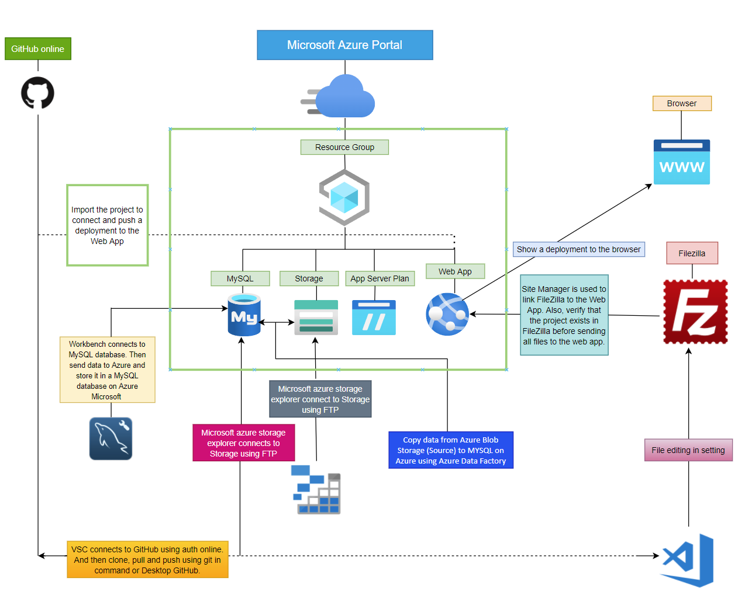

* **MUSEAI (Resource Group)**

1. **Database for MYSQL**
2. IP address based connection security
3. Workbench connects via server authentication, which includes (localhost, username, database name, and password)
4. Workbench creates new databases, tables, selects, inserts, edits, and deletes data in "Database for MYSQL."
5. PHP allows the frontend (Web App) to interact with the backend (MySQL database)
6. Copy data from Database for MYSQL to Azure Blob Storage (Source) using Azure Data Factory
7. Entity Relationship Diagram for database

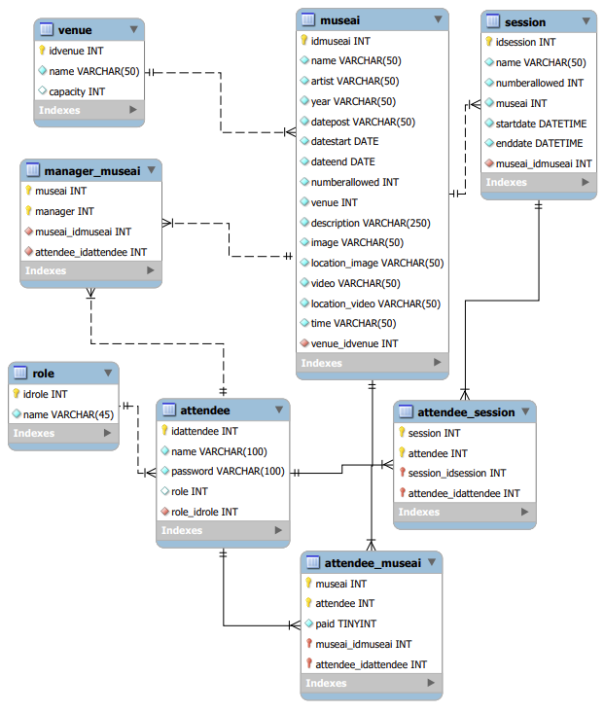

**The SQL Code (museai.sql):**

**DROP DATABASE IF EXISTS testDB;**

**CREATE DATABASE IF NOT EXISTS testDB;**

**USE testDB;**

**-- -----------------------------------------------------**

**-- Table `venue`**

**-- It is for local only**

**-- -----------------------------------------------------**

**CREATE TABLE IF NOT EXISTS `venue` (**

**`idvenue` INT NOT NULL AUTO_INCREMENT,**

**`name` VARCHAR(50) NOT NULL,**

**`capacity` INT NULL,**

**PRIMARY KEY (`idvenue`),**

**UNIQUE INDEX `name_UNIQUE` (`name` ASC));**

**INSERT INTO `venue` (`idvenue`, `name`, `capacity`) VALUES**

**(1, 'RIT', 1);**

**-- -----------------------------------------------------**

**-- Table `museai`**

**-- It is for showing all data to all roles only**

**-- -----------------------------------------------------**

**CREATE TABLE IF NOT EXISTS `museai` (**

**`idmuseai` INT NOT NULL AUTO_INCREMENT,**

**`name` VARCHAR(50) NOT NULL,**

**`artist` VARCHAR(50) NOT NULL,**

**`year` VARCHAR(50) NOT NULL,**

**`datepost` VARCHAR(50) NOT NULL,**

**`datestart` DATE NOT NULL,**

**`dateend` DATE NOT NULL,**

**`numberallowed` INT NOT NULL,**

**`venue` INT NOT NULL,**

**`description` VARCHAR(10000) NOT NULL,**

**`image` VARCHAR(50) NOT NULL,**

**`location_image` VARCHAR(50) NOT NULL,**

**`video` VARCHAR(50) NOT NULL,**

**`location_video` VARCHAR(50) NOT NULL,**

**`time` VARCHAR(50) NOT NULL,**

**`qrCodeImage` VARCHAR(50) NOT NULL,**

**`whoisposted` VARCHAR(200) NOT NULL,**

**PRIMARY KEY (`idmuseai`),**

**UNIQUE INDEX `name_UNIQUE` (`name` ASC),**

**INDEX `venue_fk_idx` (`venue` ASC));**

**INSERT INTO `museai`(**

**`idmuseai`,**

**`name`,**

**`artist`,**

**`year`,**

**`datepost`,**

**`datestart`,**

**`dateend`,**

**`numberallowed`,**

**`venue`,**

**`description`,**

**`image`,**

**`location_image`,**

**`video`,**

**`location_video`,**

**`time`,**

**`qrCodeImage`,**

**`whoisposted`**

**)**

**VALUES(**

**1,**

**'The Sentinel',**

**'Unknown',**

**'Unknown',**

**'2021-11-08',**

**'2021-11-08',**

**'2050-12-29',**

**1,**

**1,**

**'Weighing in at 110 tons and measuring 73 feet, The Sentinel represents the transformative nature of education. The unique blend and juxtipostioning of materials and shapes serves to visually represent RIT s mission of shaping and improving the world through creativity and innovation.',**

**'1_Sentinel.JPG',**

**'upload/1_Sentinel.JPG',**

**'1_Sentinel.JPG',**

**'656300853',**

**'05:24:00pm',**

**'images/61b904337d69c.png',**

**'Ike Chukz'**

**),**

**(**

**2,**

**'Three Piece Recling Figure No.1',**

**'Henry Moore',**

**'2021',**

**'2021-11-08',**

**'2021-11-08',**

**'2050-12-29',**

**1,**

**1,**

**'My sculpture needs open air - sky, clouds, trees and changes of weather" states artist Henry Moore. With inspiration from the image of the reclining female figure, this sculpture is one of seven editions.',**

**'3_Reclining_Figures.jpg',**

**'upload/3_Reclining_Figures.jpg',**

**'3_Reclining_Figures.jpg',**

**'656300888',**

**'05:24:00pm',**

**'images/61ae8a06a34f4.png',**

**'Ike Chukz'**

**),**

**(**

**3,**

**'Unity',**

**'Juan Carlos',**

**'1994',**

**'2021-11-08',**

**'2021-11-08',**

**'2050-12-29',**

**1,**

**1,**

**'While each of the three pieces of this sculpture can stand on its own, together they represent the unity of science, technology, and art at RIT. Juan Carlos, received both his Bachelors and Masters of Fine Arts degrees from RITs School for American Crafts and has been a faculty member since 1994.',**

**'6_Unity.jpg',**

**'upload/6_Unity.jpg',**

**'6_Unity.jpg',**

**'656300920',**

**'05:24:00pm',**

**'images/61ae8a06a34f4.png',**

**'Ike Chukz'**

**),**

**(**

**4,**

**'Cloaked Intentions',**

**'Unknown',**

**'Unknown',**

**'2021-11-08',**

**'2021-11-08',**

**'2050-12-29',**

**1,**

**1,**

**'While certainly not the heaviest sculpture on campus this piece is still quite massive at over 4 tons. Before making RIT campus its final resting place, this piece was on display down on Park Avenue in New York City.',**

**'8_Cloaked_Intentions.jpg',**

**'upload/8_Cloaked_Intentions.jpg',**

**'8_Cloaked_Intentions.jpg',**

**'656300960',**

**'05:24:00pm',**

**'images/61ae8a06a34f4.png',**

**'Ike Chukz'**

**),**

**(**

**5,**

**'Sundial',**

**'Unknown',**

**'Unknown',**

**'2021-11-08',**

**'2021-11-08',**

**'2050-12-29',**

**1,**

**1,**

**'When this sundial was built in 1968; it was the largest one in the country. Fun fact, this instrument is only accurate four days a year. Trivia: What are those four days?',**

**'12_Sundial_ConvertedJPG.jpg',**

**'upload/12_Sundial_ConvertedJPG.jpg',**

**'12_Sundial_ConvertedJPG.jpg',**

**'656301015',**

**'05:24:00pm',**

**'images/61ae8a06a34f4.png',**

**'Ike Chukz'**

**),**

**(**

**6,**

**'Infinity Loop',**

**'Unknown',**

**'Unknown',**

**'2021-11-08',**

**'2021-11-08',**

**'2050-12-29',**

**1,**

**1,**

**'A constantly rotating Mobius strip with cross section of an equilateral triangle, this piece was originally designed to complete 12 revolutions per hour and in 1998, mechanical engineering students rebuilt the motor.',**

**'5_Infinity_Loop_ConvertJPG.jpg',**

**'upload/5_Infinity_Loop_ConvertJPG.jpg',**

**'5_Infinity_Loop_ConvertJPG.jpg',**

**'656300908',**

**'05:24:00pm',**

**'images/61ae8a06a34f4.png',**

**'Ike Chukz'**

**),**

**(**

**7,**

**'Gateway',**

**'Unknown',**

**'Unknown',**

**'2021-11-08',**

**'2021-11-08',**

**'2050-12-29',**

**1,**

**1,**

**'Donated in honor of Dr. D. Robert Frisina, RIT vice president and founding director of NTID, in recognition of 40 years of leadership and dedication to the education of deaf and hard-of-hearing people worldwide.',**

**'13_Caballero-Perez_Gateway.jpeg',**

**'upload/13_Caballero-Perez_Gateway.jpeg',**

**'13_Caballero-Perez_Gateway.jpeg',**

**'656301029',**

**'05:24:00pm',**

**'images/61ae8a06a34f4.png',**

**'Ike Chukz'**

**),**

**(**

**8,**

**'Split Cube',**

**'Unknown',**

**'Unknown',**

**'2021-11-08',**

**'2021-11-08',**

**'2050-12-29',**

**1,**

**1,**

**'Made in honor of NTIDs 10th Anniversary. This is the largest sculpture ever made by artist Carl Zollo -- weighing in at 8,000 pounds! Education visualized is what the artists concept behind the piece',**

**'14_Split_Cube_resized.jpg',**

**'upload/14_Split_Cube_resized.jpg',**

**'14_Split_Cube_resized.jpg',**

**'656301050',**

**'05:24:00pm',**

**'images/61ae8a06a34f4.png',**

**'Ike Chukz'**

**),**

**(**

**9,**

**'Tojo Memorial Garden',**

**'Unknown',**

**'2021',**

**'2021-11-08',**

**'2021-11-08',**

**'2050-12-29',**

**1,**

**1,**

**'This delicate yet extremely solid piece is a granite stone lantern presented by the parents of Yasuji Tojo, a Japanese student in the photography program that was killed in a car accident in 1964. The piece is at the center of a garden that was created in honor of Tojo and serves as a "living memorial to eternal youth.',**

**'2_Tojo_ConvertedJPG_resized.jpg',**

**'upload/2_Tojo_ConvertedJPG_resized.jpg',**

**'2_Tojo_ConvertedJPG_resized.jpg',**

**'656300866',**

**'05:24:00pm',**

**'images/61ae8a06a34f4.png',**

**'Ike Chukz'**

**),**

**(**

**10,**

**'In Art, Science and Life, What is the Question?',**

**'Unknown',**

**'2021',**

**'2021-11-08',**

**'2021-11-08',**

**'2050-12-29',**

**1,**

**1,**

**'Inspired by the spirit and energy of nature, each of the 13 panels of tempered glass weigh over 400 pounds. The artist, Nancy Gong, studies at RIT in the School for American Craftsmen. Along the top of piece is a binary code that represents a quote from American novelist ,Thomas Berger (1024-2014), "The art and science of asking questions is the source of all knowledge.',**

**'5_Infinity_Loop_ConvertJPG.jpg',**

**'upload/5_Infinity_Loop_ConvertJPG.jpg',**

**'5_Infinity_Loop_ConvertJPG.jpg',**

**'656300968',**

**'05:24:00pm',**

**'images/61ae8a06a34f4.png',**

**'Ike Chukz'**

**),**

**(**

**11,**

**'Tiger Statue',**

**'Unknown',**

**'2021',**

**'2021-11-08',**

**'2021-11-08',**

**'2050-12-29',**

**1,**

**1,**

**'Designed to be a permanent symbol of RIT tradition, pride, and spirit, the artist spent hours observing Siberian tigers and attempts with this sculpture to capture the essence of the animal in their natural habitat.',**

**'11_Tiger.jpg',**

**'upload/11_Tiger.jpg',**

**'11_Tiger.jpg',**

**'656300999',**

**'05:24:00pm',**

**'images/61ae8a06a34f4.png',**

**'Ike Chukz'**

**),**

**(**

**12,**

**'Green Wall',**

**'Unknown',**

**'2021',**

**'2021-11-08',**

**'2021-11-08',**

**'2050-12-29',**

**1,**

**1,**

**'This piece is living! It contains 1,776 green plants, together which contribute to air quality and aesthetics.',**

**'7-Green wall.jpg',**

**'upload/7-Green wall.jpg',**

**'7-Green wall.jpg',**

**'656300940',**

**'05:24:00pm',**

**'images/61ae8a06a34f4.png',**

**'Ike Chukz'**

**),**

**(**

**13,**

**'Oak Tree Chairs',**

**'Unknown',**

**'2021',**

**'2021-11-08',**

**'2021-11-08',**

**'2050-12-29',**

**1,**

**1,**

**'Made to commemorate the 50th Anniversary of RITs Henrietta campus, this piece was created from a winning design from RITs annual T-Minus 151 Industrial Design Challenge and is made from wood of a century-old oak tree that stood at RITs entrance.',**

**'10_Oak_Tree_Chairs.png',**

**'upload/10_Oak_Tree_Chairs.png',**

**'10_Oak_Tree_Chairs.png',**

**'656300988',**

**'05:24:00pm',**

**'images/61ae8a06a34f4.png',**

**'Ike Chukz'**

**),**

**(**

**14,**

**'Book of the World',**

**'Unknown',**

**'2021',**

**'2021-11-08',**

**'2021-11-08',**

**'2050-12-29',**

**1,**

**1,**

**'For the artist form and content are inseparable, which is pretty clear with this piece that hangs suspended from the librarys ceiling. It is a book full of maps and charts being approached as objects that can be read on many levels.',**

**'4_Book_of_the_World_Resized.jpg',**

**'upload/4_Book_of_the_World_Resized.jpg',**

**'4_Book_of_the_World_Resized.jpg',**

**'656300899',**

**'05:24:00pm',**

**'images/61ae8a06a34f4.png',**

**'Ike Chukz'**

**);**

**-- -----------------------------------------------------**

**-- Table `session`**

**-- -----------------------------------------------------**

**CREATE TABLE IF NOT EXISTS `session` (**

**`idsession` INT NOT NULL AUTO_INCREMENT,**

**`name` VARCHAR(50) NOT NULL,**

**`numberallowed` INT NOT NULL,**

**`museai` INT NOT NULL,**

**`startdate` DATETIME NOT NULL,**

**`enddate` DATETIME NOT NULL,**

**PRIMARY KEY (`idsession`));**

**-- -----------------------------------------------------**

**-- Table `attendee`**

**-- It is a role for admin, manager, ntid and register**

**-- It is connected by role**

**-- -----------------------------------------------------**

**CREATE TABLE IF NOT EXISTS `attendee` (**

**`idattendee` INT NOT NULL AUTO_INCREMENT,**

**`username` VARCHAR(100) NOT NULL,**

**`password` VARCHAR(100) NOT NULL,**

**`fullname` VARCHAR(200) NOT NULL,**

**`role` INT NULL,**

**PRIMARY KEY (`idattendee`),**

**INDEX `role_id` (`role` ASC));**

**-- -----------------------------------------------------**

**-- Table `manager_museai`**

**-- museai for all data in admin.php**

**-- manager for only some data in museai.php**

**-- nuseai and manager are showed new record when insert at the same time.**

**-- -----------------------------------------------------**

**CREATE TABLE IF NOT EXISTS `manager_museai` (**

**`museai` INT NOT NULL,**

**`manager` INT NOT NULL,**

**PRIMARY KEY (`museai`, `manager`)**

**);**

**-- -----------------------------------------------------**

**-- Table `ntid_museai`**

**-- museai for all data in admin.php**

**-- ntid for only some data in museai.php**

**-- nuseai and ntid are showed new record when insert at the same time.**

**-- -----------------------------------------------------**

**CREATE TABLE IF NOT EXISTS `ntid_museai` (**

**`museai` INT NOT NULL,**

**`ntid` INT NOT NULL,**

**PRIMARY KEY (`museai`, `ntid`)**

**);**

**-- -----------------------------------------------------**

**-- Table `attendee_museai`**

**-- -----------------------------------------------------**

**CREATE TABLE IF NOT EXISTS `attendee_museai` (**

**`museai` INT NOT NULL,**

**`attendee` INT NOT NULL,**

**`paid` TINYINT NOT NULL DEFAULT 0,**

**PRIMARY KEY (`museai`, `attendee`));**

**-- -----------------------------------------------------**

**-- Table `attendee_session`**

**-- -----------------------------------------------------**

**CREATE TABLE IF NOT EXISTS `attendee_session` (**

**`session` INT NOT NULL,**

**`attendee` INT NOT NULL,**

**PRIMARY KEY (`session`, `attendee`));**

**-- -----------------------------------------------------**

**-- Table `role`**

**-- -----------------------------------------------------**

**CREATE TABLE IF NOT EXISTS `role` (**

**`idrole` INT NOT NULL AUTO_INCREMENT,**

**`name` VARCHAR(45) NOT NULL,**

**PRIMARY KEY (`idrole`),**

**UNIQUE INDEX `name_UNIQUE` (`name` ASC));**

**INSERT INTO `role` (`name`) values ('admin'),('museai manager'),('museai ntid'),('attendee');**

**-- --------------------------------------------------------**

**--**

**-- Table structure for table `admin`**

**--**

**CREATE TABLE `admin` (**

**`id` int(11) NOT NULL,**

**`username` varchar(50) NOT NULL,**

**`email` varchar(50) NOT NULL,**

**`password` varchar(50) NOT NULL**

**);**

**--**

**-- Dumping data for table `admin`**

**--**

**INSERT INTO `admin` (`id`, `username`, `email`, `password`) VALUES**

**(1, 'admin', 'admin@admin.com', '9ae2be73b58b565bce3e47493a56e26a');**

**-- --------------------------------------------------------**

**--**

**-- Table structure for table `deleteduser`**

**--**

**CREATE TABLE `deleteduser` (**

**`id` int(11) NOT NULL,**

**`email` varchar(50) NOT NULL,**

**`deltime` timestamp NOT NULL DEFAULT CURRENT_TIMESTAMP**

**);**

**-- --------------------------------------------------------**

**--**

**-- Table structure for table `feedback`**

**--**

**CREATE TABLE `feedback` (**

**`id` int(11) NOT NULL,**

**`sender` varchar(50) NOT NULL,**

**`reciver` varchar(50) NOT NULL,**

**`title` varchar(100) NOT NULL,**

**`feedbackdata` varchar(500) NOT NULL,**

**`attachment` varchar(50) NOT NULL**

**);**

**-- --------------------------------------------------------**

**--**

**-- Table structure for table `notification`**

**--**

**CREATE TABLE `notification` (**

**`id` int(11) NOT NULL,**

**`notiuser` varchar(50) NOT NULL,**

**`notireciver` varchar(50) NOT NULL,**

**`notitype` varchar(50) NOT NULL,**

**`time` timestamp NOT NULL DEFAULT CURRENT_TIMESTAMP**

**);**

**-- --------------------------------------------------------**

**--**

**-- Table structure for table `users`**

**--**

**CREATE TABLE `users` (**

**`id` int(11) NOT NULL,**

**`name` varchar(50) NOT NULL,**

**`email` varchar(50) NOT NULL,**

**`password` varchar(50) NOT NULL,**

**`gender` varchar(50) NOT NULL,**

**`mobile` varchar(50) NOT NULL,**

**`designation` varchar(50) NOT NULL,**

**`image` varchar(50) NOT NULL,**

**`status` int(10) NOT NULL**

**);**

**--**

**-- Indexes for dumped tables**

**--**

**--**

**-- Indexes for table `admin`**

**--**

**ALTER TABLE `admin`**

**ADD PRIMARY KEY (`id`);**

**--**

**-- Indexes for table `deleteduser`**

**--**

**ALTER TABLE `deleteduser`**

**ADD PRIMARY KEY (`id`);**

**--**

**-- Indexes for table `feedback`**

**--**

**ALTER TABLE `feedback`**

**ADD PRIMARY KEY (`id`);**

**--**

**-- Indexes for table `notification`**

**--**

**ALTER TABLE `notification`**

**ADD PRIMARY KEY (`id`);**

**--**

**-- Indexes for table `users`**

**--**

**ALTER TABLE `users`**

**ADD PRIMARY KEY (`id`);**

**--**

**-- AUTO_INCREMENT for dumped tables**

**--**

**--**

**-- AUTO_INCREMENT for table `admin`**

**--**

**ALTER TABLE `admin`**

**MODIFY `id` int(11) NOT NULL AUTO_INCREMENT, AUTO_INCREMENT=2;**

**--**

**-- AUTO_INCREMENT for table `deleteduser`**

**--**

**ALTER TABLE `deleteduser`**

**MODIFY `id` int(11) NOT NULL AUTO_INCREMENT, AUTO_INCREMENT=21;**

**--**

**-- AUTO_INCREMENT for table `feedback`**

**--**

**ALTER TABLE `feedback`**

**MODIFY `id` int(11) NOT NULL AUTO_INCREMENT, AUTO_INCREMENT=19;**

**--**

**-- AUTO_INCREMENT for table `notification`**

**--**

**ALTER TABLE `notification`**

**MODIFY `id` int(11) NOT NULL AUTO_INCREMENT, AUTO_INCREMENT=18;**

**--**

**-- AUTO_INCREMENT for table `users`**

**--**

**ALTER TABLE `users`**

**MODIFY `id` int(11) NOT NULL AUTO_INCREMENT, AUTO_INCREMENT=20;**

**COMMIT;**

1. **App Server Plan**
2. Operating System (Windows, Linux)
3. Region (West US, East US, Central US, etc)
4. Number of VM instances (XAMPP, WAMP, MAMP and LAMP)
5. Size of VM instances (Small, Medium, Large)
6. Pricing tier (Free, Shared, Basic, Standard, Premium, PremiumV3, Isolated)
7. **Microsoft Azure Storage**
8. Azure Blob storage offers three types of resources

* The storage account
* A container in the storage account
* A blob in a container

1. Sign up for a new Microsoft Azure Storage account.
2. The Azure Storage Explorer app connects to Microsoft Azure Storage.
3. Storing files in a shared folder for easy access
4. Picture files such as jpg, png, and gif
5. Video files such mp4, and mov
6. Document files such txt, csv, zip and docx
7. Programming language files such java, html, css, python, php, ts, etc
8. Storing audio streaming
9. Storing data for analysis
10. Writing to the log file
11. Copy data from Azure Blob Storage (Source) to Database for MYSQL using Azure Data Factory

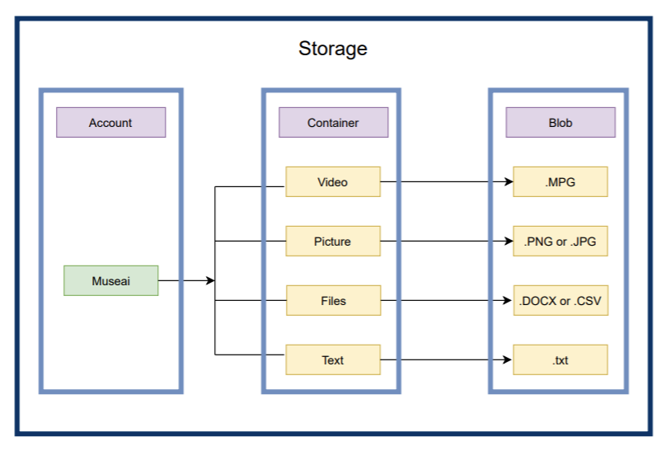

1. **Web Application**
2. Using HTML, JavaScript, and Bootstrap to create a new web app
3. FileZilla and the Web App are linked using Site Manager on the FileZilla.
4. Before uploading all files to the Web App, double-check that the project exists in the FileZilla.
5. Web App interaction with database using PHP
6. Integrate Visual Studio Code with GitHub
7. FileZilla edits the code using visual studio code
8. Pay for the Azure compute resources.

* **Web Portal**

1. Web Application using HTML, JavaScript, Bootstrap and PHP 7.4
2. Progressive Web Application using Node for React and Typescript, it is used for only mobile applications.

**Azure Data Factory**

* It's a data integration and ETL (extract, transform, load) service that runs on the cloud.
* The goal of Azure Data Factory is to load data from one or more data sources into a format that can be processed such as:

1. Copy data from Azure Blob Storage (source) to a MySQL database
2. Copy data from a MySQL database to Azure Blob Storage (source)

* It can create data-driven pipelines for orchestrating data movement and transforming data at scale

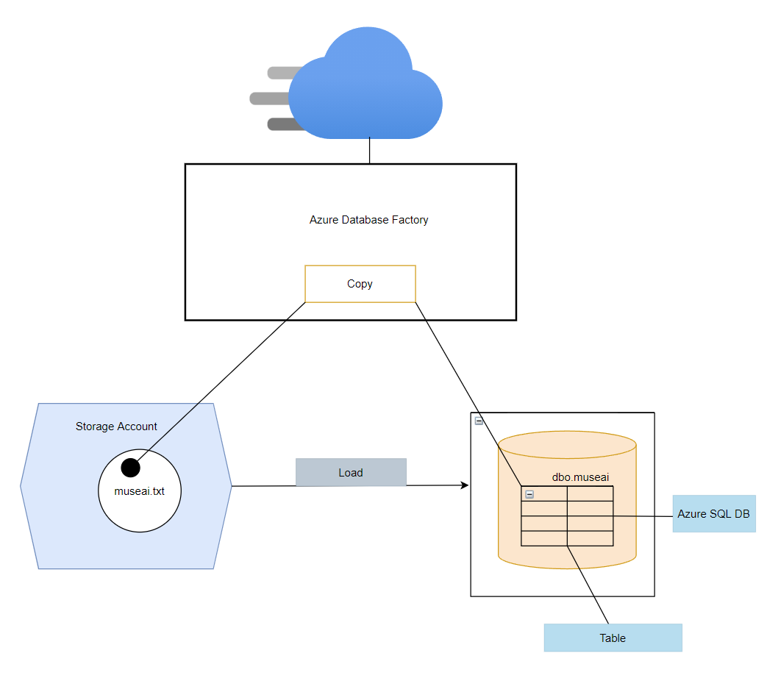

**Contextual Diagram**

* **Museai Database**

1. It will be displayed all information on both Web App and Progressive Web Application
2. The information will be changed by the authority only (Admin)

* **Web Application**

1. The information will be viewed by the admin
2. The information will be inserted a new record by the admin
3. The information will be changed by the admin
4. The information will be deleted by the admin

* **Progressive Web Application**

1. The information will be view by the user
2. The user will be able to search and find specific information

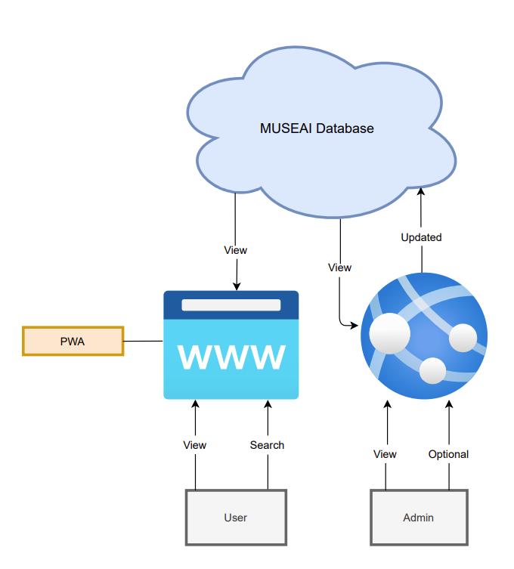

**Operational Model**

* **Rules**

1. There will have three roles (Admin, Manager and user) on Web Application
2. Provide Museai administrative with an account for admin, manager and user
3. Only the admin role should have the ability to view all the information, change information and upload/remove static information.
4. The manager should be able to view the information, edit and delete on own his/her page.
5. The user should be able to view and search the information.

* **Security**

1. Admin should be able to access all roles accounts for security reasons
2. Both manager and user should not be able to access admin accounts
3. We will maintain session security through the use of secure web tokens
4. The museai’s url should be blocked or forbid from accessing of the hacker

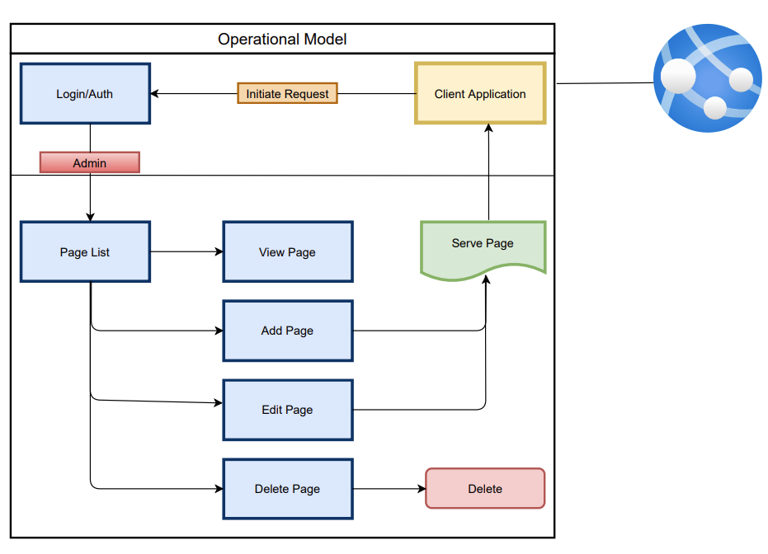

**Progressive Web App**

* Research

1. What are progressive web apps?
2. A progressive web application is a sort of web-based application that is constructed with common web technologies such as HTML, CSS, and JavaScript.
3. Goal
4. It is intended to work on any platform that uses a standards-compliant browser, including both desktop and mobile devices.
5. The web application can be published online by the developers.
6. The app can be added to the user's home screen.
7. Publishing the app to digital distribution systems that look like Apple App Store or Google Play is optional.
8. Other….
9. Others….
10. Others….

* Develop Feature

1. Comparison
2. Native apps are programs created using a single technology specialized to a certain platform (Android or iOS).
3. The functionalities of a native app and a web app are combined in hybrid mobile app development.
4. Progressive web apps run in a web browser, even though they give the user a native experience.
5. Difference

* Diagram

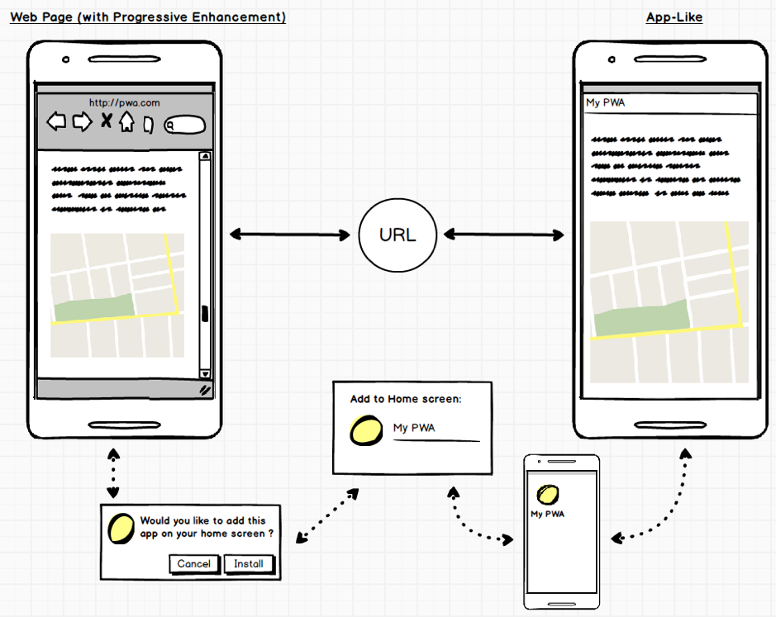

* Timeline???
* Others….

**Web Application**

1. Language
2. HyperText Markup Language (HTML)
3. Cascading Style Sheets (CSS)
4. Bootstrap
5. SCSS
6. JavaScript (JS)
7. Typescript (TS)
8. Hypertext Preprocessor (PHP)
9. Backend
10. Nodejs
11. PHP
12. Frontend
13. Web Application with FTP
14. Progressive Web Application

**Application Architecture**

* **Client Application**

1. Angular
2. React
3. WordPress



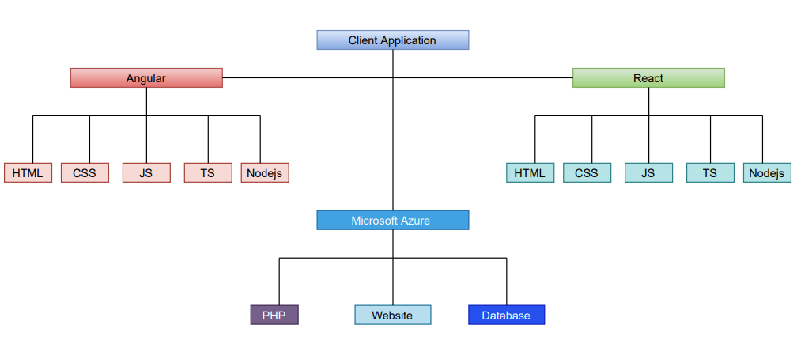

* **Server Application**

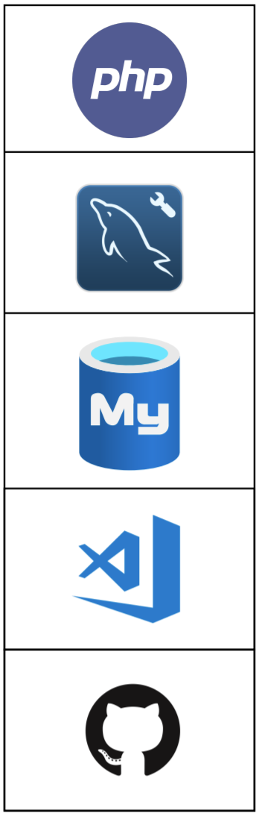

**Server Architecture**

**NodeJS runs both:**

1. Server (database, Javascript, restful and postman) .
2. And client (React and Typescript)

* **Model View Controller (MVC)**

1. The **model** will be backed by data in the database as well as the Museai API. The data layer will sufficiently abstract the structure contained in the backend, and provide **CRUD** methods.
2. The **view** and **controller** will be connected to the API as this is how the user (through the frontend) will interface with the application. The API will follow RESTful principles using different HTTP methods semantically, and sending information in JSON format.
3. The **view** will consist of the data returned by **GET** requests to the API.
4. The **controller** will consist of listeners to **POST**, **PUT**, **DELETE** and other methods on the API.

* **Cross Origins Resources Sharing (CORS)**

1. It allows us to relax the security to an API.
2. In Nodejs, there is a cors that allows the React port to obtain data from Nodejs for the user's display.

* **Route**

1. It is a section of express code that associates an HTTP verb (GET), a URL path/pattern and a function that is called to handle that pattern.

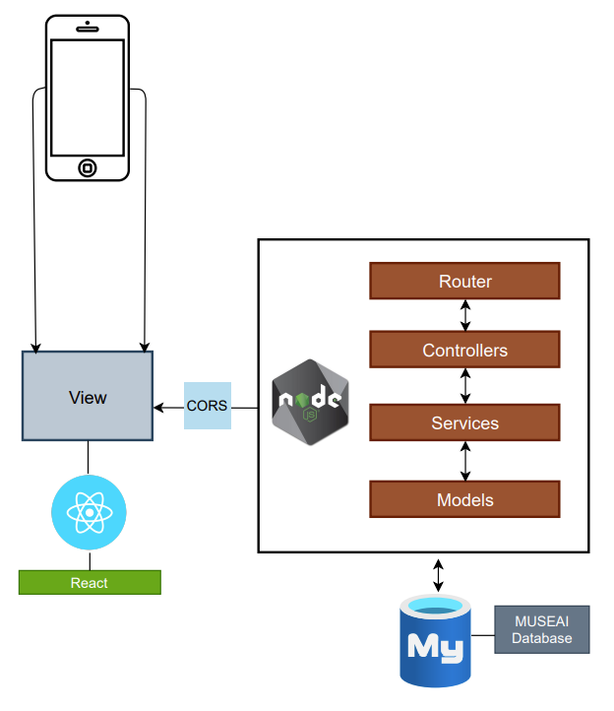

**The UML Class:**

**Cited Work**

[**https://www.ijert.org/a-study-on-progressive-web-apps-as-a-unifier-for-native-apps-and-the-web**](https://www.ijert.org/a-study-on-progressive-web-apps-as-a-unifier-for-native-apps-and-the-web)

[**https://portal.azure.com/#@rit0.onmicrosoft.com/resource/subscriptions/53b32298-95b5-4794-b3d9-3eea9f199f7b/resourceGroups/MUSEAI/overview**](https://portal.azure.com/#@rit0.onmicrosoft.com/resource/subscriptions/53b32298-95b5-4794-b3d9-3eea9f199f7b/resourceGroups/MUSEAI/overview)

[**https://docs.microsoft.com/en-us/azure/app-service/quickstart-php?pivots=platform-linux**](https://docs.microsoft.com/en-us/azure/app-service/quickstart-php?pivots=platform-linux)

[**https://docs.microsoft.com/en-us/azure/app-service/deploy-configure-credentials?tabs=cli**](https://docs.microsoft.com/en-us/azure/app-service/deploy-configure-credentials?tabs=cli)

[**https://docs.microsoft.com/en-us/azure/app-service/deploy-configure-credentials?tabs=portal**](https://docs.microsoft.com/en-us/azure/app-service/deploy-configure-credentials?tabs=portal)

[**https://docs.microsoft.com/en-us/azure/app-service/deploy-configure-credentials?tabs=portal**](https://docs.microsoft.com/en-us/azure/app-service/deploy-configure-credentials?tabs=portal)

[**https://docs.microsoft.com/en-us/azure/role-based-access-control/troubleshooting**](https://docs.microsoft.com/en-us/azure/role-based-access-control/troubleshooting)

[**https://docs.microsoft.com/en-us/azure/active-directory-b2c/identity-provider-github?pivots=b2c-user-flow**](https://docs.microsoft.com/en-us/azure/active-directory-b2c/identity-provider-github?pivots=b2c-user-flow)

[**https://docs.microsoft.com/en-us/sql/azure-data-studio/download-azure-data-studio?view=sql-server-ver15**](https://docs.microsoft.com/en-us/sql/azure-data-studio/download-azure-data-studio?view=sql-server-ver15)

[**https://www.c-sharpcorner.com/article/integrate-azure-sql-database-with-php-website/**](https://www.c-sharpcorner.com/article/integrate-azure-sql-database-with-php-website/)

[**https://social.technet.microsoft.com/wiki/contents/articles/34850.integrate-azure-sql-database-with-php-website.aspx**](https://social.technet.microsoft.com/wiki/contents/articles/34850.integrate-azure-sql-database-with-php-website.aspx)

[**How to Upload Files to Azure - FileZilla Pro**](https://filezillapro.com/docs/v3/cloud/uploading-files-to-azure/)

[**How to Connect to an Azure SQL Database (adamtheautomator.com)**](https://adamtheautomator.com/connect-to-azure-sql-database/)

**FTP to Azure Blob Storage:**

[**https://stackoverflow.com/questions/39992173/ftp-to-azure-blob-storage**](https://stackoverflow.com/questions/39992173/ftp-to-azure-blob-storage)

[**https://azure.microsoft.com/en-us/features/storage-explorer/#security**](https://azure.microsoft.com/en-us/features/storage-explorer/#security)

**Connection to sql database from storage:**

[**https://docs.microsoft.com/en-us/azure/data-factory/tutorial-copy-data-tool**](https://docs.microsoft.com/en-us/azure/data-factory/tutorial-copy-data-tool)